Homo Noxis
Narrator Blueprint and Big Bang Rewrite Method
For The Veil of Light - Chapter 1 and full Book 1 rewrite pass

A forbidden witness remembers his childhood with the precision of a man who later understood the legal machinery that destroyed him.

Version: working doctrine after the Chapter 1 opening calibration and Foucault Hall redesign

1. Purpose and authority of this document
This document is the working doctrine for rewriting Homo Noxis - The Veil of Light after the narrator change. It gathers the narrator contract, the long oral macro-phrase method, the controlled revelation rules, the Switzerland/Horizon time-point, the new Hall of Ceremony geometry, and the Chapter 1 event order. It is meant to be used before every prose pass, especially before rewriting Chapter 1.
The aim is not to make the prose merely first-person. The aim is to make every scene feel like testimony: a child inside the Mountain, remembered by the man the Mountain later turned into evidence.

Non-negotiable governing sentence
The narrator is a forbidden witness remembering his childhood with the precision of a man who later understood the legal machinery that destroyed him.
Kailan lived the scene as a proud, gifted, bodily child inside ceremony and institution.
Sa-Kylian narrates after removal, exile, and legal understanding, but does not spoil every future mechanism early.
Paul Morgan is the preserver, retranscriber, or transmitter of the testimony; Paul frames but does not become the chapter voice.
The Mountain remains morally complicated: home, school, church, court, machine, refuge, and trap at once.

2. The narrator in time
The voice belongs to Sa-Kylian after the Mountain has lost him, not to Kailan speaking live inside childhood. The testimony is shaped after Switzerland/Horizon has begun, and after the narrator has acquired enough distance to understand categories such as office, standing, proof, permission, witness, and legal sequence. Yet he is not fully modern. He does not translate the Mountain into ordinary outsider terms unless the frame explicitly requires it.
Name | Narrative function
Kailan | Child before office; proud, embodied, hungry, watched, not yet legally shaped by Light.
Sa-Kailan | Candidate of Light; named, cut, corrected, admitted into first doors and first humiliations.
Va-Kailan | Veil of Light; dangerous bearer of sight, proof, and partial knowledge.
Sa-Kylian | Exile/Horizon name; the later witness who narrates with precision, shame, loyalty, and bitterness under discipline.

Switzerland / Horizon time-point
The narrator speaks from after the Mountain, with Switzerland as the first major outside containment horizon.
He has seen windows, documents, churches he is told not to enter, abundance without visible rationing, and the strangeness of outside trust.
Those outside comparisons should remain rare in Book 1. They may appear only where the retrospective witness needs a cold point of contrast.
The voice should not become modern memoir. It remains translated from a mind formed by the Mountain.

3. The two temporal layers
Layer | How it behaves
Young Kailan inside the scene | Body, pride, irritation, hunger, embarrassment, desire for Va-Sheva, need for Va-Raedin approval, impatience with withheld knowledge.
Adult Sa-Kylian after the fact | Legal precision, structural knowledge, restraint, grief, unwilling fairness toward the Mountain, awareness that proof travels.

The prose should move between these layers without always announcing the shift. Avoid repetitive formulae like "later I understood". Use object-led transitions instead: a sandal, a cut, a gate, a lamp, a stone, a prayer mark, a water bowl, a record.
Type | Example
Good | I thought the wardens faced the crowd because crowds required discipline. They did. I did not yet understand that Shield watched obedience with the same seriousness as rebellion.
Bad | Later I understood this foreshadowed the trial and my legal condemnation.

4. The long oral macro-phrase method
The successful Chapter 1 calibration came from abandoning short, choppy explanatory prose and moving into long spoken sentence-units: pressured, bodily, institutional, with internal turns. This is a Celine-informed calibration, not a mechanical imitation or pastiche. The point is not decoration. The point is breath under pressure.

Macro-phrase philosophy
A sentence should often feel like a thought trying to survive its own momentum.
The line should begin in a physical detail, pass through institution, and end in a small hard truth.
The voice can be bitter, but it should be disciplined; rage is usually too small for this testimony.
The sentence should carry contradiction: home and prison, mercy and rationing, ritual and machinery, beauty and containment.
The prose should sound spoken by someone who has rehearsed his wound until it became exact.

Macro-phrase anatomy
Concrete bodily entry: feet hurt, collar scratches, breath shortens, thumb throbs, lamp hisses.
Institutional expansion: who permitted this warmth, who placed this light, who counted this water, who witnessed this silence.
Child reaction: pride, irritation, hunger, embarrassment, desire to be seen, fear of correction.
Adult pressure: what the child could not yet name, what later became legal or dangerous.
Small brutal closure: a sentence that lands as law, cost, or shame rather than abstract explanation.
Concrete humiliation -> institutional machinery -> adult wound -> hard little truth.

5. Sentence-length and rhythm protocol
The method is not to make every sentence long. It is to let important narrative tissue breathe in long macro-phrases, then cut it with short dialogue, ritual answers, or hard institutional lines. The chapter must not become monotonous.
Unit | Target average | Soft minimum | Soft maximum | Use
General non-dialogue narration | 65-105 words average | 35 words | 140 words | Use for ordinary retrospective tissue.
Ceremonial / architectural set pieces | 85-125 words average | 50 words | 165 words | Use for Hall, Ascension, high ritual, Tomb, Trial.
High-pressure macro-phrases | 95-135 words average | 70 words | 180 words | Use sparingly when the sentence must carry body + institution + doom.
Dialogue lines | 3-18 words average | 1 word | 35 words | Dialogue may cut the long prose sharply.
Paragraphs | 90-220 words average | 35 words | 300 words | Usually one to three macro-phrases; keep paragraph flow visually readable.

Hard rule: if the prose becomes choppy, merge observations into longer pressure-units. If it becomes foggy or abstract, cut back to body, object, office, and consequence.

Rhythm rule
After two or three long macro-phrases, insert a short line of dialogue, an action, or a concrete image.
After dialogue, allow one reflective sentence only if the scene needs it. Do not explain every exchange.
Keep aphorisms load-bearing. Do not stack more than two in a row.
The prose may rise near scripture, but it must not compete with scripture.

6. Tone distribution
Tone | Frequency | Notes
Retrospective testimony | Constant | Main tissue of the book.
Young bodily immediacy | Frequent early; less frequent after Veil | Feet, hunger, collar, shame, Va-Sheva, approval hunger.
Architectural/institutional perception | Frequent | Rooms, halls, routes, pillars, gates, permissions, offices.
Legal/procedural foreshadowing | Increasing across Book 1 | Standing, proof, witness, sequence, category, bearer.
Sacred/liturgical elevation | Rare | Scripture, Ascension, Martyrdom, Trial, Cataclysm.
Dry humour | Controlled doses | Va-Raedin correction, Ka-Syphiron warmth, body discomfort, institutional absurdity.

7. What made the new Chapter 1 opening work
It opened from the body, not from lore: discomfort first, doctrine second.
The Hall was not described as scenery but as permission made architectural.
Every sacred object also performed a mechanical, legal, or social function.
The adult narrator added pressure but did not explain the whole future plot.
The sentences were long enough to carry contradiction but exact enough not to become fog.
The voice allowed Kailan to be proud, young, brilliant, and wrong at the same time.
The Mountain was not called evil; its logic was allowed to work. That was the horror.
The Mountain did not need to be stupid in order to destroy him. It needed to be coherent.

8. Knowledge discipline and reveal schedule
The adult narrator knows more than the child, but must not burn the book early. He may foreshadow. He may mark danger. He may say that a thing mattered. He must not use future technical language before the story earns it.
Stage | Allowed | Forbidden / caution
Chapter 1 | Visible ritual only: Hall, pendulum faces, prayer distribution, office positions, naming, cut, first correction. | Do not name Foucault, Earth rotation, latitude, round Earth, seismology, resonance, wave propagation.
Chapters 2-5 | Light optics, seeing staged, water bending sight, threshold return, Shield pattern logic. | Avoid explaining Faith science in modern terms.
Chapter 8 | Faith as rhythm, echo, sound, hidden physical knowledge; deeper cross-Kahir hints become speakable. | This is where resonance/seismology-adjacent vocabulary may begin, if the scene earns it.
Tomb / Trial | Proof travels; carried sight becomes legal danger; sealed knowledge becomes portable object. | Legal/procedural voice may intensify.
Horizon | Outside language and scientific framing may enter more freely, but Kailan should still think through Mountain categories first. | Do not make him suddenly modern.

Use "rhythm older than the day" instead of technical explanation in Chapter 1.
Use "the line returned" rather than explaining why it returned.
Use "the faces changed" rather than explaining Earth rotation.
Use "Faith kept the count" rather than naming the physics behind the count.
The narrator can say he did not yet know what Faith was measuring, but he should not say what it was.

9. Kahir narration rules
Kahir | Narrative meaning | Object language
Light | Young Kailan sees truth, beauty, intelligence; adult sees arranged seeing and dangerous reproducibility. | Eye, angle, lamp, mirror, aperture, where to stand, who placed the light.
Faith | Not merely belief. Faith is rhythm, memory, prayer, breath, stone receiving sound, story under pressure. | Breath, rhythm, echo, silence, prayer, return, words placed so fear behaves.
Balance | Not boring. Balance is survival intelligence, cost, transformation, resource, pressure. | Water, measure, jar, heat, ration, waste, body condition, cost.
Shield | Prevention before explanation. Closure under uncertainty. Mercy as containment. | Threshold, gate, hand, seal, body held, route closed, danger named before seen.
Justice | Sequence, witness, record, consequence; not goodness but ordered ruin or correction. | Record, order, fact, witness, correction, standing, lawful horror.

10. Hall of Ceremony canon for Chapter 1
The Hall is no longer a rectangular ceremonial room with a dais. It is a vast hollow cone mined upward inside the Mountain to house the pendulum. The central space is forbidden because the pendulum crosses it and because the code-circle belongs to no one Kahir. This architecture must govern all ceremony blocking.
Central forbidden circle: flat circular field beneath the pendulum, also the code-circle. No ordinary body crosses it.
Pillar ring: five huge Kahir pillars placed around the forbidden circle at the points of a pentagram.
Pentagram structure: pillars are linked by floor ribs and upward architectural support systems; doctrine and engineering become one shape.
Outer ambulatory: the great circular corridor where people, families, candidates, servants, and processions stand or move.
Kahir doors: each Kahir has its specific door or arch opening from the outer ambulatory.
Keepers stand at pillar stations. Veils stand behind or beside them. Candidates occupy assigned Kahir sectors. Common people remain in the outer ring.
The central circle is not a stage. It is an absence made lawful.
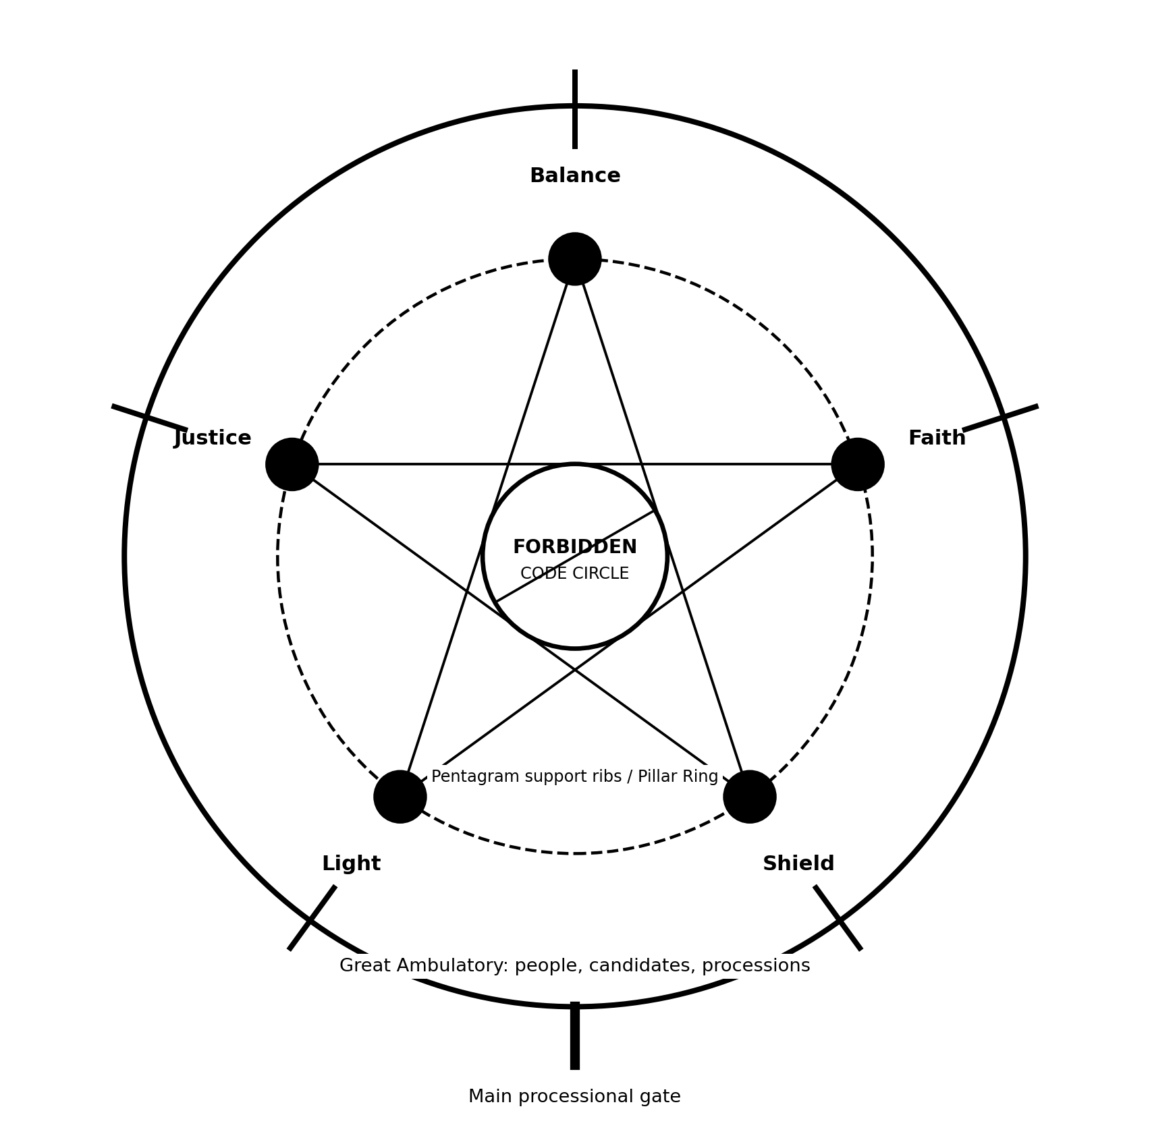
Top-down ceremonial plan: forbidden central circle, five-pillar pentagram ring, outer ambulatory, Kahir doors.

Vertical form
The cone rises far above ordinary human scale, mined upward into the Mountain.
At the crown is the suspension cap from which the Thread descends.
The pendulum bob hangs in the central void and moves across the forbidden circle.
The five pillars are vertical, not slanted ribs; they support an upper annular ring and the vast mined hollow above.
The outer ambulatory remains high enough for processions but lower than the overwhelming central crown.
From the floor, the worshipper feels small not because the Hall is wide, but because it is impossibly high.

11. Pendulum and prayer logic for Chapter 1
The pendulum has a two-faced bob: one face is Godward, one face is Beastward.
Because the Hall is circular and full, some worshippers see the God-face while others across the Hall see the Beast-face.
As the pendulum line changes over time, every Kahir station receives both faces in equal measure.
This equality should be visible as ritual, not explained as science.
The people do not all experience the same prayer image at the same time. That is the point.
Faith controls the rhythm, the marking, the words, and the public interpretation.
Publicly: sometimes God is petitioned; sometimes the Beast is addressed as chained foe; sometimes the defence is blessed; sometimes the Outsider is kept beyond the Threshold.
Privately: the narrator may hint that Faith was keeping a rhythm older than ordinary prayer, but he must not name the technical meaning in Chapter 1.
The faces changed. No office kept one face forever. Faith made the Hall wait long enough for every pillar to be accused and blessed in turn.

12. Chapter 1 sequence of events
% 1-The Hall of Ceremony is introduced as a mined vertical cone: an impossible upward hollow cut into the Mountain to house the pendulum
% 2-The central forbidden circle is established: no one enters it, because the pendulum crosses it and because the code-circle belongs to no single Kahir
% 3-The five great pillars are described around the forbidden circle: Balance, Faith, Shield, Light, Justice, joined by pentagram ribs that make structure look like doctrine
% 4-The outer ambulatory is introduced: the people, families, servants, candidates, and processions stand in the circular corridor around the pillar-ring
% 5-Kailan’s bodily discomfort grounds the scale: sore feet, scratched robe, heat, echo, height, and the terrifying sense that the Hall is too large for human ceremony
% 6-The spatial order of the ceremony is established: Keepers stand at their pillar stations, Veils behind or beside them, Candidates in assigned Kahir sectors, common people in the outer ring
% 7-The pendulum is seen above the forbidden circle: the Thread descends from the high crown, the two-faced bob moves through the void, and the floor slowly remembers its line
% 8-Kailan notices the two-faced pendulum logic without understanding it: because the Hall is full and circular, some worshippers face the God-face while others, across the Hall, see the hidden Beast-face; as the pendulum’s line slowly changes over time, each Kahir station is made to receive both faces in equal measure
% 9-The adult narrator foreshadows the secret carefully without naming it: Faith did not merely command prayer-direction, it kept a rhythm older than the day, a rhythm by which every office was made to face God, face the Beast, and return again without any one Kahir possessing the meaning
% 10-The chime begins the rite: sound travels up the cone, strikes the crown, descends through the five pillar-ribs, and makes the whole Hall answer before any person speaks
% 11-Faith enters from its outer Kahir door through the ambulatory: attendants carry water bowls around the forbidden circle without crossing it
% 12-Ka-Mereth is brought beneath the Faith pillar, not to a dais: old, nearly gone, seated at the edge of the pillar-ring where the pendulum’s line can pass before her but never touch her
% 13-Va-Elun enters behind Ka-Mereth: pilgrim mantle, scars at the throat, the proof of the Labyrinth carried in the body rather than explained
% 14-Kailan stares at Va-Elun’s scars until Va-Raedin corrects him: Light’s candidate-sector is placed by the Light pillar, far enough to see, not close enough to belong
% 15-The five waters are placed at the five pillar bases: Balance measures, Faith speaks, Shield holds the exits, Justice witnesses, Light illuminates, each office acting from its own station
% 16-Ka-Mereth questions Va-Elun before the Faith pillar: the Chamber of the Last Prayer is named, and the Hall’s height turns the words into a vertical dread
% 17-Kailan looks across the forbidden centre toward Va-Sheva at the Shield pillar: desire, distance, rank, and threshold logic are made spatially visible
% 18-The transfer of Faith occurs: the cowl passes from Ka-Mereth to Va-Elun, who rises as Ka-Elun while the pendulum continues moving through the unowned centre
% 19-Ka-Elun declares the doctrine of hidden survival: the Mountain remains because hands are divided, memory does not wander, and no one hand may hold the whole
% 20-Ka-Mereth is carried out through the Faith door: not through the centre, never across the forbidden circle, but around the ambulatory and back into prayer
% 21-The ceremony does not dissolve: the five pillars remain occupied, and the Hall reorders itself for the smaller but sharper Light naming
% 22-Ka-Syphiron summons Kailan from the Light sector toward the edge of the forbidden circle, stopping him before the line that no Candidate may cross
% 23-Kailan sees the central code-circle properly for the first time: a flat circular field beneath the pendulum, marked in ways he cannot yet read and forbidden to all ordinary bodies
% 24-Ka-Syphiron asks the Light catechism: Candidate, Veil, Keeper; Kailan gives the rehearsed answers but feels the forbidden centre pulling meaning away from the words
% 25-Kailan’s dangerous inner answer forms: hidden things still have shape, and if they have shape then perhaps they can be found
% 26-Ka-Syphiron cuts Kailan’s thumb and presses the blood to the eastern Light mark, not in the centre but at the permitted edge of Light’s authority
% 27-Kailan is named Sa-Kailan, Candidate of Light: the name enters not the whole Hall, but the Light sector, the records, and the doors that will now answer or refuse him
% 28-The Mountain acknowledges him: fingers strike stone around the ambulatory, and the sound travels through the five pillars like hard rain
% 29-Va-Raedin gives the first private correction: Kailan answered poorly, but not uninterestingly; praise arrives as danger rather than comfort
% 30-Ka-Elun closes the rite with prayer: God is invoked as provider, defender, binder of the Beast, keeper of the Outsider beyond the threshold, and witness to the Keepers’ divided charge
% 31-The public prayer logic is clarified through action, not explanation: some prayers ask God to provide, some ask Him to keep His promise, some bless the defence He gave the hidden people, some command the Beast to remember chain, master, friend, and foe, and some ask that the Outsider remain beyond the Threshold
% 32-Shield begins releasing the Hall by sectors: not everyone moves at once; each Kahir door opens in sequence, the outer ambulatory empties by permission
% 33-Va-Raedin binds Sa-Kailan’s thumb and gives practical orders for the first Light lesson: report early, do not eat heavily, do not arrive proud
% 34-Sa-Kailan looks once more across the forbidden circle toward Va-Sheva: she is already Shield again, watching exits, not him
% 35-The Hall empties around the pendulum: lamps dim, pillars darken, the God-face disappears into shadow for some, the Beast-face disappears into shadow for others, and the hidden equality of the faces remains unspoken
% 36-Sa-Kailan follows Va-Raedin through the Light door, leaving behind the central circle he has been taught not to cross and has now begun to want to understand

13. Prose engines to rotate
Engine | Use
Body engine | Use discomfort, hunger, heat, sore feet, robe, blood, breath. Best in Ch.1 and early training.
Architecture engine | Use rooms, pillars, gates, lines of sight, surfaces, height, doors, passage logic.
Institution engine | Use office, permission, witness, sequence, standing, category, charge.
Object doctrine engine | Let lamp, water, blade, token, cowl, cord, bowl, pillar, or pendulum teach without essay.
Dialogue pressure engine | Let Va-Raedin, Va-Sheva, Ka-Syphiron, Ka-Elun cut the narration. Reflect once, then move.
Liturgy engine | Reserve for scripture and ceremony. Keep elevated, but controlled.

14. Dialogue policy
Dialogue should be sharp, formal, and pressure-bearing.
Do not turn dialogue into explanation.
Let doctrine emerge as correction.
Va-Raedin approval is often a wound disguised as precision.
Va-Sheva care is often containment, not softness.
Ka-Syphiron may carry warmth and humour, especially before martyrdom, but warmth must remain under office.
Type | Example
Good | “Do you understand?” / “Yes.” / “No. You agree.” / That correction stayed with me longer than the permission did.
Bad | He explained that in Shield doctrine understanding was unnecessary at thresholds because obedience came first.

15. Aphorism and philosophy policy
Philosophy must pass through objects. It should rarely appear as a free-standing thesis. The narrator may make hard sentences, but only when the scene has earned them through body, object, or procedure.
Good aphorisms: Curiosity is not free. Proof travels. Seeing is not permission. The floor lied. The weight remembered.
Use aphorisms as hinges, not wallpaper.
Never stack several abstract sentences unless a scene has reached ceremonial or legal climax.
When in doubt, cut the abstraction and return to a thing being held, opened, counted, sealed, lit, or crossed.

16. Lexical bans and caution words for early chapters
Rule | Words / substitutions
Do not use in Chapter 1 | seismology; resonance; Foucault; latitude; Earth rotation; round Earth; wave propagation; inertial plane; physics explanation.
Use instead | rhythm older than the day; the line returned; the faces changed; Faith kept the count; the Hall waited; the floor remembered.
Do not overuse | later I understood; foreshadowed; secret; truth; evil; prison; freedom.
Use carefully | permission; standing; witness; sequence; office; proof; category; return; threshold.

17. Output workflow for rewrite passes
Work from the current chapter map before drafting prose.
Rewrite in blocks of roughly 800-1,500 words for best quality, unless the user explicitly asks for a full chapter in one pass.
Preserve LaTeX structure and scripture exactly unless explicitly instructed otherwise.
Use first person throughout the chapter body, except formal scripture and archival/frontmatter.
Keep prose in long oral macro-phrases, but break with short dialogue and concrete action.
At the end of each block, check that no future-sensitive word has slipped in too early.
Before final assembly, smooth transitions between blocks so the voice feels continuous.

18. Quick calibration checklist
Does the scene begin in body, object, or space rather than explanation?
Does each paragraph do at least two jobs?
Is young Kailan allowed to be proud and wrong?
Is adult Sa-Kylian exact without spoiling?
Does the Mountain’s logic work before it horrifies?
Have scripture passages been preserved exactly?
Have early technical revelations been withheld?
Are macro-phrases long enough to breathe but precise enough to cut?
Is every abstract idea attached to a thing: lamp, water, gate, pillar, blade, token, record, cowl, pendulum?
Does the final sentence of the passage leave pressure, not explanation?

